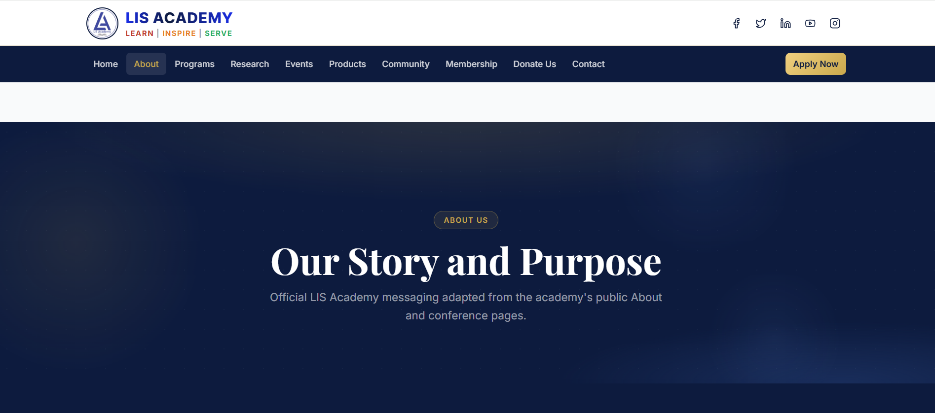
The LIS Academy (Library & Information Science Academy) is a professional Public Charitable Trust established to advance the Profession and assist Libraries with state-of-the-art technology and Librarians with continuous skill development. The primary focus of the Academy is to provide need-based service to the different types of Libraries in the country and to work for the advancement of the Library and Information Science (LIS) profession at large.
The LIS Academy, with a tagline of “Learn Inspire Serve,” aims to become the best, most active, and dynamic professional body by supporting professionals with the essential knowledge, skills, and values of librarianship through innovative and cutting-edge technology and by adopting best and fair practices and innovative ideas.
The mission of the LIS Academy is to spread multi-dimensional utility and overall growth of Librarianship through education, literature, research, publications, outsourcing, training programs, consultation, and collaboration.
Along with the above primary objectives, LIS Academy works with Higher Education Institutions to improve their research and publication productivity by conducting workshops and seminars for their Teachers and Research Scholars and helping them enhance their research productivity. Accordingly, the Academy also undertakes consultancy to prepare institutions for accreditations such as NBA, NAAC, and NIRF.
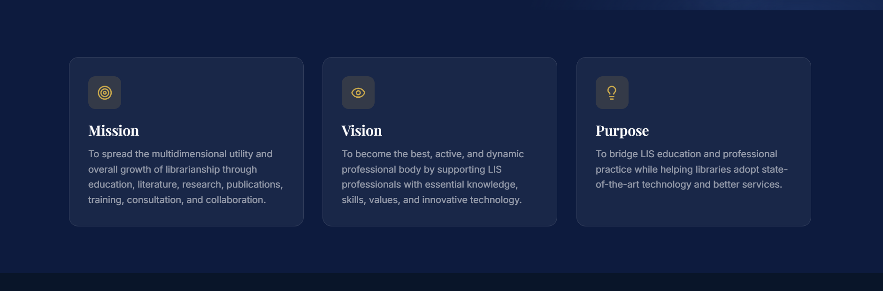
VISION
LIS Academy contributes to the essential knowledge, skills, and values of librarianship and the information professions through innovative and cutting edge technology.

MISSION
The mission of the LIS Academy is to spread multi-dimensional utility and overall growth of profession of Librarianship, through education, literature, research, publications, outsource, training programs, consultation and collaboration.

PURPOSE
The LIS Academy is a professional Public Charitable Trust dedicated to the advancement of the Library and Information Science (LIS) profession. Its primary purpose is to provide need-based services to libraries and support LIS professionals through continuous skill development and technological innovation

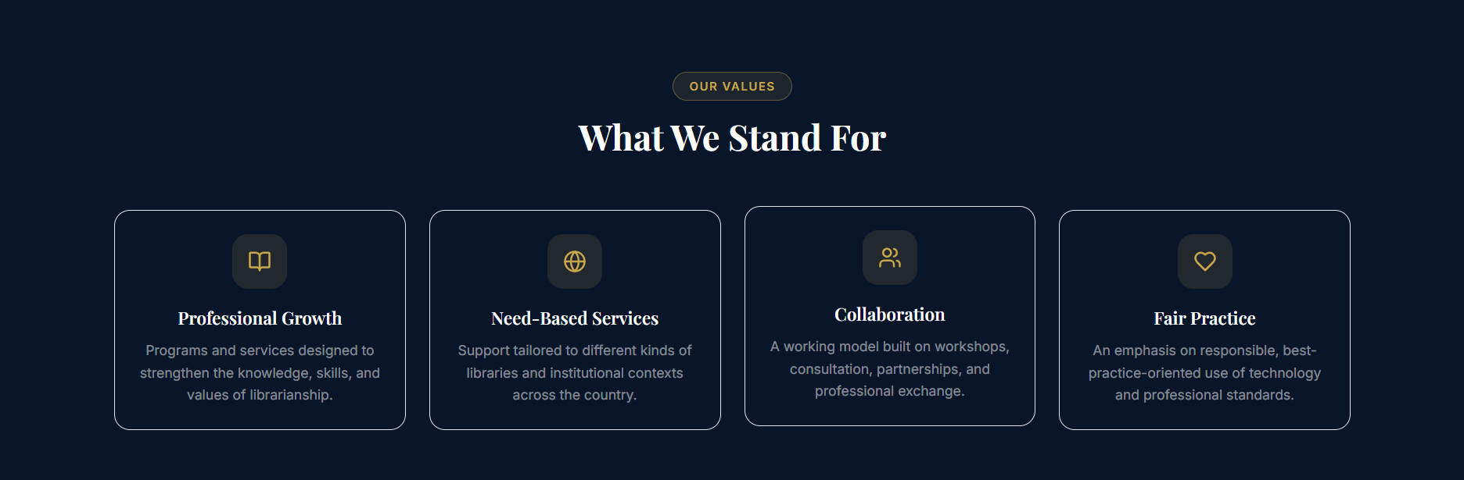
PROFESSIONAL GROWTH
The LIS Academy is a professional public charitable trust headquartered in Bengaluru, Karnataka, dedicated to the development of the library profession through technology and continuous skill development. Under its tagline "Learn, Inspire, Serve," the academy offers various avenues for professional growth, ranging from entry-level "finishing schools" to advanced leadership programs.

NEED-BASED SERVICES
- Technology Support & Customization: Development and customization of open-source software for libraries and technology solutions.
- Research & Academic Consultancy: Guidance for NAAC, NBA, and NIRF accreditation and workshops to boost research productivity.
- Professional Development & Training: LISA Finishing School for enhancing soft skills and technical competencies, and leadership programs for future librarians.
- Distinguished Lecture Series: Monthly sessions featuring esteemed academics sharing insights.
- Career & Academic Support: Live-streaming career counseling for LIS students and events like LISACON for knowledge sharing.
- Digital Divide Initiatives: Efforts to connect with rural professionals to bridge the digital divide in public libraries.

COLLABORATIONS
The LIS Academy actively collaborates with diverse stakeholders, including academic institutions, national and international professional associations, and government bodies, to drive innovation and professional growth in the library sector.

FAIR PRACTICE
The LIS Academy integrates "Fair Practice" as a foundational pillar of its mission, aiming to adopt "best and fair practices and innovative ideas" in all professional activities. This commitment ensures that library and information science (LIS) services remain transparent, ethical, and unbiased.

